黑光
Dark Light
为华乐团而作
for Chinese Orchestra

李智恒
Lee Ji Heng

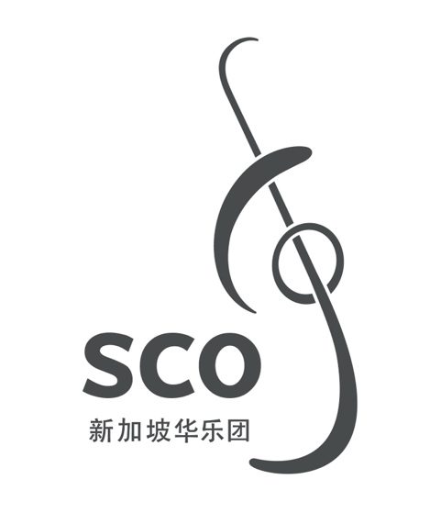

00/000
沉默黑光
Dark Light
为华乐团而作
for Chinese Orchestra

李智恒
Lee Ji Heng
(2011)
8'

黑光
Dark Light

ISMN

Copyright © Singapore Chinese Orchestra Co. Ltd. All rights reserved.

版权所有, 未经许可, 不得以任何形式印刷、复制、扫描或发行。
Unauthorised printing, reproduction, scanning or distribution is strictly prohibited
without the express permission of the copyright holder.

印刷于新加坡。
Printed in Singapore.

新加坡华乐团有限公司
珊顿道7号
新加坡大会堂
新加坡邮区 068810

Singapore Chinese Orchestra Co. Ltd.
7 Shenton Way
Singapore Conference Hall
Singapore 068810

网站 Website: www.sco.com.sg
电邮 Email: aa@sco.com.sg
电话 Telephone: (65) 6557 4026
传真 Fax: (65) 6557 2756

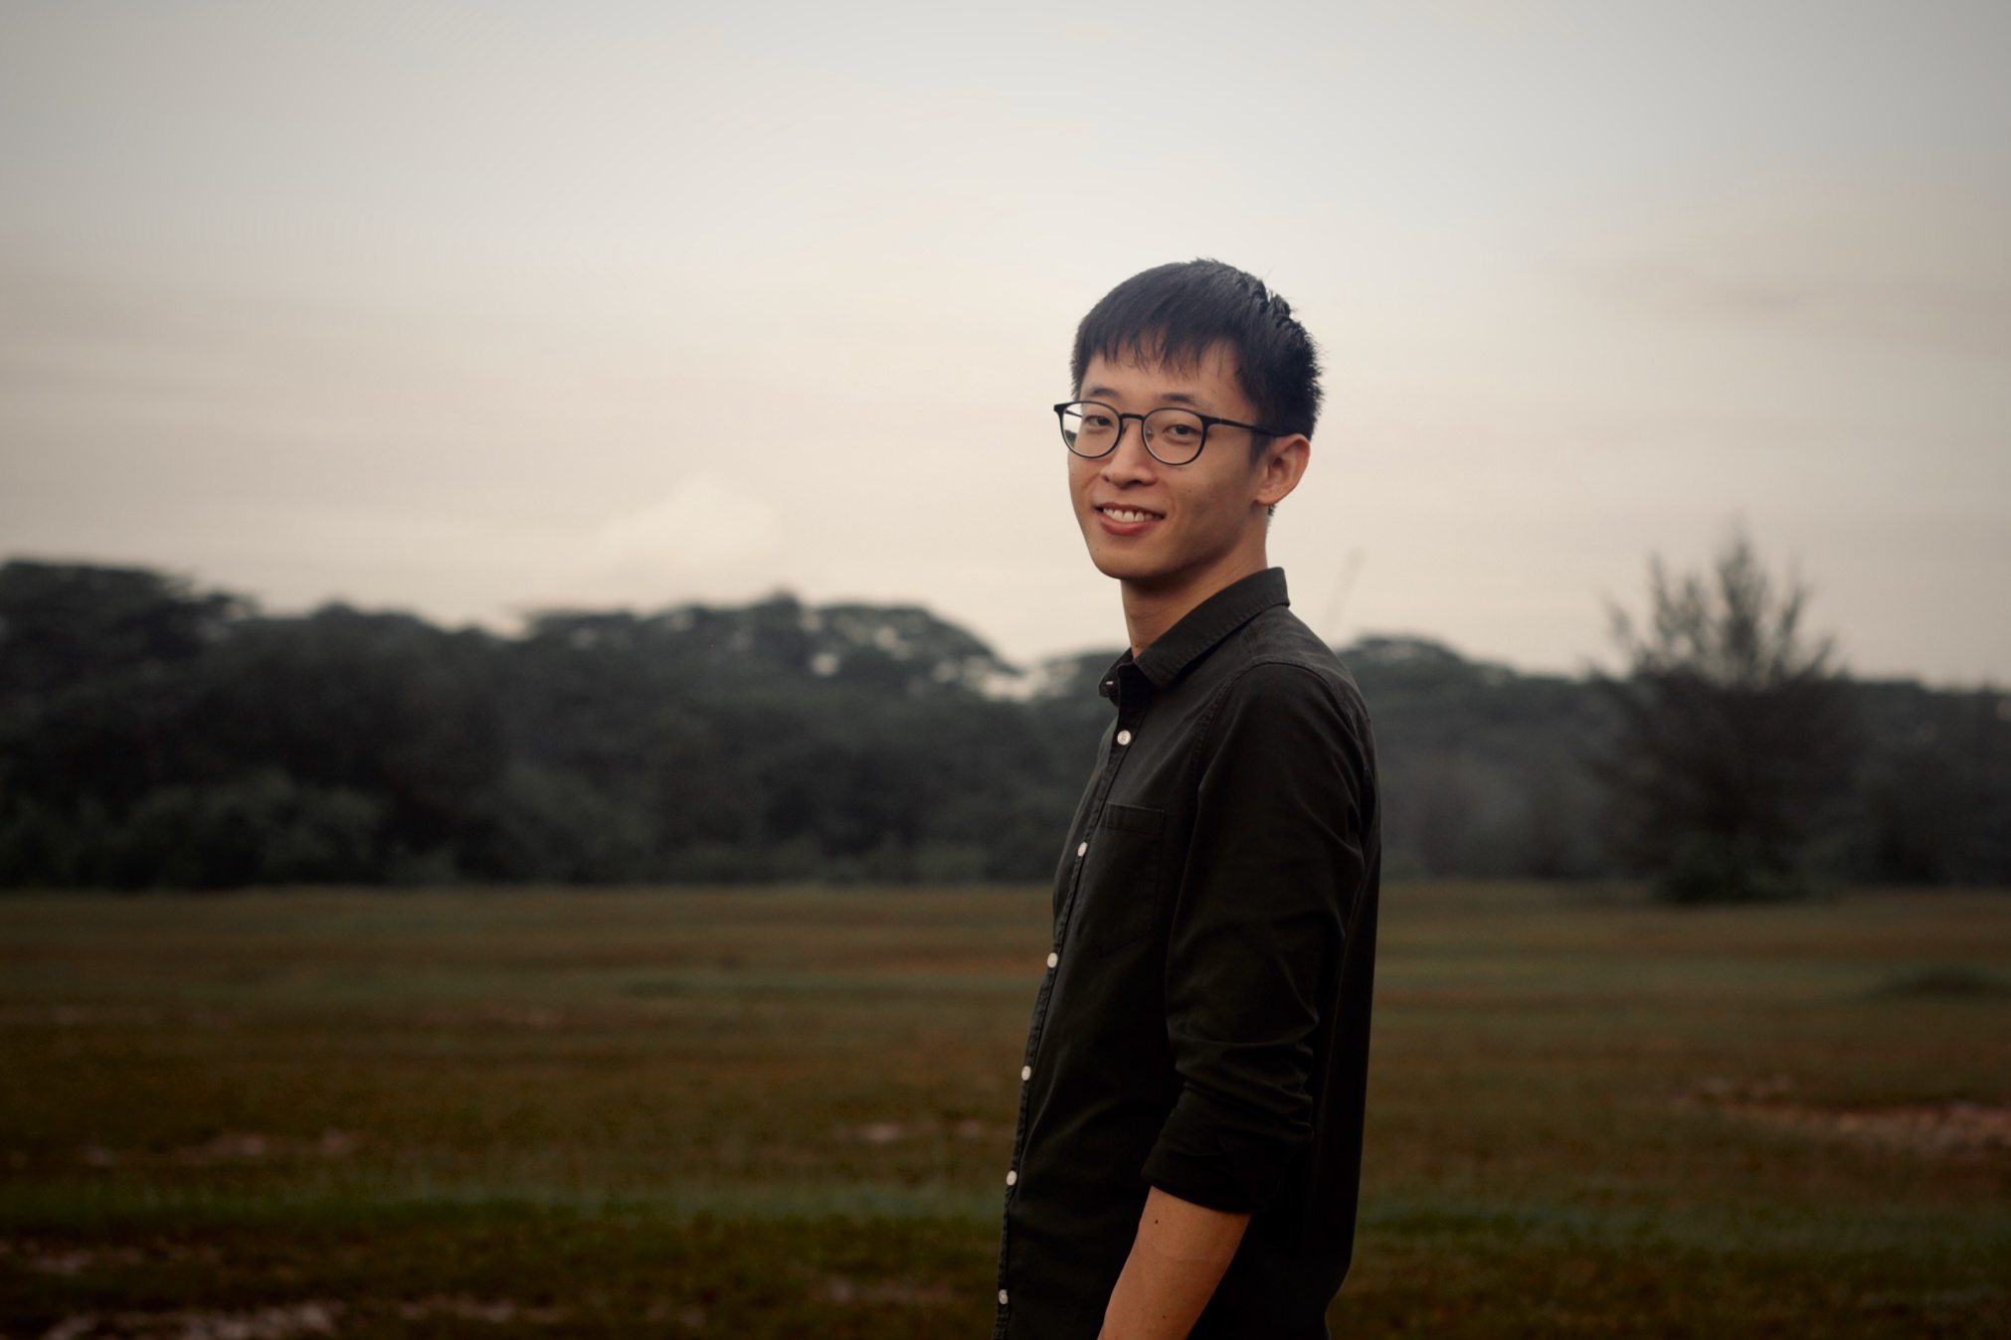
传Biography
新加坡作曲家李智恒在莱佛士书院念书时担任学校吉他团的学生指挥，从而开始为团内外的朋友作曲、编曲。智恒在莱佛士书院选读了 A 水准音乐考试，毕业之后仍继续为学弟们写曲子，其中包括 Quintet (作为书院与来自科隆的 Ensemble musikFabrik 的合作演奏曲，由 Peter Veale 老师指挥)，以及 听说... heard that... ，由曾伟成老师指挥的西洋及华乐弦乐团联合演奏。智恒在 2011年由新加坡华乐团举办的新加坡国际华乐作曲大赛获颁新加坡作曲家奖，获奖作品 黑光 由新加坡华乐团公演及录音 (叶聪老师指挥)，载入获奖作品专辑。
智恒之前获颁新加坡教育部教学奖学金，在剑桥大学 (格尔顿学院) 读音乐本科，毕业于 2017年 6月。他在剑桥的作曲教师包括 Richard Causton, Jeremy Thurlow 及 Cheryl Frances-Hoad。他也曾与 Martin Ennis, Tim Watts 及 Gareth Wilson 等教授上音乐学课程。他曾经参加过格尔顿学院教堂合唱团以及学院音乐协会筹办的音乐会，以 2016年考试成绩获颁学院的 Sophia Turle 奖学金及 Phyllis Tillyard 奖。就读剑桥大学期间，智恒尝试为各种乐器组合作曲，其中作品包括 Maranâ thâ 降临节颂歌 (由伊利合唱团演奏/Matthew Rudd 先生指挥)、为剑桥大学华乐团创作的 短奏曲 (Short Piece)、The Ocean Breathes (共十二声部和三面吊钹)，以及一首献给格尔顿学院风琴学者 Lucy Morrell 的 Three Movements for Organ 。
智恒 2018年毕业于英国伦敦皇家音乐学院，获颁作曲硕士。他受益于 Jean Cater 女士及 Gordon Marshall 教慷慨授捐赠的 Levelhulme Arts 奖学金，与 Jonathan Cole 博士学习作曲。在伦敦求学的期间，他的曲子 pe_ple_sc_ns 在国家肖像艺廊举办的 Taylor-Wessing 摄影肖像奖展音乐会上，与其他学生的作品一同演出。智恒近年来经常与学院音乐学生们合作，从而出炉的新作品包括 repose I、EXCITATIONS 及 the caged bird sings... 走出校园，他为弦乐四重奏写的 [autofocus] 在 Dartington 国际暑期学校由 Heath Quartet 首演；他为女高音与长笛写的 aḍḍā আড্ডা 也在意大利音乐出版社 Diaphonia Edizioni 主办的 Minelli-Dacey Duo ‘Flute-like-Voice’ 作品召集赛中获得两次公演，也由该出版社出版。
目前，智恒在新加坡当初级学院音乐教师，边教书边作曲。

Singaporean composer Ji Heng Lee began writing and arranging music for his peers in the Guitar ensemble (of which he was Music Director) and other student-run orchestras when he was studying in Raffles Institution (Singapore), where he read Music at the A-Level. Since graduating, he has continued to compose pieces for school juniors, including a Quintet conducted by Peter Veale as part of a collaboration with the Cologne-based Ensemble musikFabrik, as well as a chamber piece, heard that…, performed by a combined (Western and Chinese) string orchestra under Wei Shing Chan. In 2011, Ji Heng received the Singaporean Composer Award for his orchestral piece, Dark Light, in the Singapore International Competition for Chinese Orchestral Composition. His piece was premiered by the Singapore Chinese Orchestra under the direction of Tsung Yeh, and has also been recorded as part of an album featuring winning pieces from the competition.
Under a teaching scholarship awarded by the Singapore Ministry of Education, Ji Heng read the Music Tripos at University of Cambridge (Girton College), and graduated in June 2017. He took composition lessons with teachers including Richard Causton, Jeremy Thurlow and Cheryl Frances-Hoad, and also academic lessons with Martin Ennis, Tim Watts and Gareth Wilson, along with several others. He was involved in the College's Chapel Choir and numerous recitals organised by the Music Society. In 2016, he was awarded the Sophia Turle Scholarship and Phyllis Tillyard Prize in recognition of his academic performance. During his time at Cambridge, Ji Heng wrote for a diverse range of ensembles. Past projects include a prize-winning Advent carol Maranâ thâ premiered by Ely Consort under Matthew Rudd, a Short Piece for Cambridge University Chinese Orchestra, a setting of a poem The Ocean Breathes for twelve solo voices and three suspended cymbals, as well as Three Movements for Organ dedicated to Lucy Morrell, who was Senior Organ Scholar (2015-2018) at Girton College.
Ji Heng graduated from Royal College of Music (RCM) London with a Master of Music (MMus) in Composition. He studied with Jonathan Cole under a Leverhulme Arts Scholarship, supported by donors Ms Jean Cater and Professor Gordon Marshall. During his time in London, his pe_ple_sc_ns was played in the Taylor-Wessing Photographic Portrait Prize Exhibition Concert at the National Portrait Gallery, along with pieces written by other RCM composition students in response to selected portraits. Collaborations with musicians associated with RCM also brought forth pieces such as repose I, EXCITATIONS, and the caged bird sings… Beyond college, his [autofocus] for string quartet was premiered by the Heath Quartet at Dartington International Summer School, and his aḍḍā আড্ডা won two performances in the Diaphonia Edizioni Minelli-Dacey Duo 'Flute-like-Voice' Call for Scores, and has been published by Diaphonia Edizioni.
Presently, Ji Heng is teaching music in a junior college in Singapore, and seeks to keep on composing alongside his teaching job.

乐曲介绍Synopsis
《黑光》描绘了两个乐团(中国南方吹管乐团􏰀印度尼西亚“加麦兰”打击乐团)􏰁行之音景。两
方即将逼近之时，对立的乐器音色(指的是柔亮的吹管音色与尖短的打击音色)引起了紧张气氛。 两方各一心想利用乐器的声洪量、音度与复杂的节奏击败对方。后来，两方之间起的冲突涌上了高 潮。两方各自激情的呐喊响彻云霄。接着，一片萦绕人心的寂静拨穿了一位漂亮女孩的心。女孩站 在两方之间，在沉淀未解的寂静之下开始歌吟，歌声迷人动听...

Dark Light paints the musical soundscape of two musical bands crossing paths — a Wind Ensemble from Eastern- China and Javanese Gamelan troop from Indonesia. As the two bands draw closer to each other, their opposing sonorities (smooth winds versus sharp, plucked or mallet attacks) present an uncomfortable tension. Furiously attempt to outplay each other with blaring clashing pitches, interlocking rhythms and sheer volume of sounds, the conflict heightens and bursts with a passionate outcry from each band. A moment of intense stillness in the wake of the conflict rips through the heart of a hauntingly beautiful girl standing in the midst of the bands. She sings euphoniously beneath an unsettled silence...

编制Instrumentation
梆笛 Bangdi
曲笛 Qudi
新笛Xindi
箫 Xiao
高音笙 Gaoyin Sheng
中音笙 Zhongyin Sheng
低音笙 Diyin Sheng
高音唢呐 Gaoyin Suona
次中嗩吶 Cizhongyin Suona
低音嗩吶 Diyin Suona

扬琴 Yangqin
柳琴 Liuqin
琵琶 Pipa
中阮 Zhongruan
三弦 Sanxian
大阮 Daruan

5 打击乐 Percussion
I: 定音鼓 Timpani, 大堂鼓 Datanggu, 堂鼓 Xiaotanggu
II: 排鼓 Paigu, 铃鼓 Tambourine
III: 云锣 Yunluo, 木鱼 Woodblock, 吊钹 Suspended Cymbal, 军镲 Crash Cymbals
IV: 编钟 (下层) Bianzhong (bottom row), 大军鼓 Bass Drum
V: 锣 Gong, 颤音琴 Vibraphone,大军鼓 Bass Drum

高胡 Gaohu
二胡 Erhu
中胡 Zhonghu
大提琴 Violoncello
低音提琴 Contrabass

